Game Design Document

Fill up the following document

1. Write the title of your project.

Protectors of the Earth.

1. What is the goal of the game?

The goal will be to shoot down as many aliens and monsters as possible by the lassers from your ship and try not to die by the lassers coming from the aliens and monsters. Points will be awarded as per the number of aliens and monsters dead.

1. Write a brief story of your game.

It’s the year 2050 and the earth is slowly deteriorating due to global warming. The environment is going from bad to worse within secconds, the only hope the human race had of survivng was the new spaceship they created. The spaceship was named as “Starflight”, it was launched in 2048 with two people piloting it. Many assumed them dead as nobody had heard from the spaceship, but alas there was always a ray of hope. There was a call from the spaceship, their prayers were answerd! The call was made public and evrybody was not only terrified but also relived, there was hope for their future! The call stated that their search for extestential life was over as they found aliens willing to help! Soon the aliens that had arrived with the Starflight started mending the earth slowly. The earth once again become clean and healthy and the humans vowed to keep it that way. The aliens had asked to visit whenever they wanted in return and we humans happily agreed, but there were other aliens out there who found earth more habbitual than their own planet and decided to take it over. But we humans decided to protect our new earth with the knowledge and tecnological advancements left to us by the other nice aliens.

1. Which are the playing characters of this game?

* Playing characters are the ones who respond to the user based on the input from the user.
* Cars, monkeys, dinos, wizards, etc., are the playing characters in the game.

|  |  |  |
| --- | --- | --- |
| Number | Character Name | What can this character do? |
| 1 | Starflight | Shoot lassers and move up and down, it hit more that 10 times, the game ends |

1. Which are the Non-Playing Characters of this game?

* Non-Playing characters are the ones that don't have an action or behavior when the user interacts with the game.
* Hurdles, stones, bananas, coins, etc., are non-playing characters in the game.

|  |  |  |
| --- | --- | --- |
| Number | Character Name | What can this character do? |
| 1 | Alien #1 | Coming from the right and moving towars starflight shooting lassers,  Dies in 1 hit |
| 2 | Alien #2 | Coming from the right and moving towars starflight shooting lassers, dies in 2 hits |
| 3 | Alien #3 | Coming from the right and moving towars starflight shooting lassers, dies in 3 hits |
| 4 | Alien #4 | Coming from the right and moving towars starflight shooting lassers, dies in 4 hits |
| 5 | Earth | Stays behind starlight and does not move. |

1. Draw your imagination of this game. What does this game look like?

* Draw the game either on your computer or on paper.
* Add images of the game scenes to show each of the playing and non-playing characters at least once.

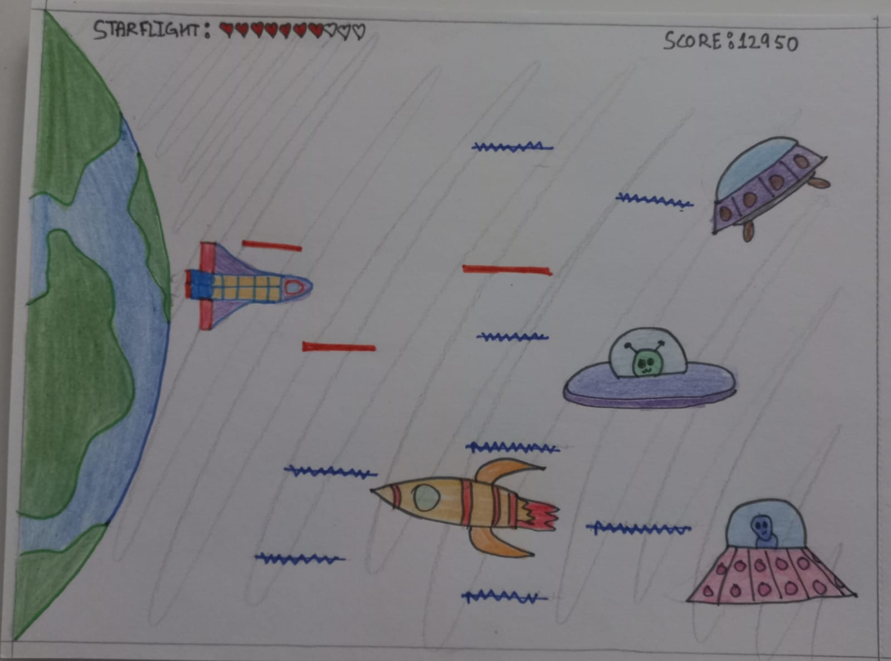

1. How do you plan to make your game engaging?

By making it harder and harder as times goes. Insirting cool animations of aliens and spaceships. Adding noises for lassers and hits.